Network Upgrade for B & B Manufacturing

Matthew J Rondel

Western Governors University

**Table of Contents**

Summary 3

Review of Other Work 5

Changes to the Project Environment 5

Methodology 8

Project Goals and Objectives 10

Project Timeline 11

Unanticipated Requirements 12

Conclusions 12

Project Deliverables 13

References 14

References 14

Appendix A 15

Before and After Network Topology and Site Map 15

Appendix B 16

Title of Appendix 16

Appendix C 17

Title of Appendix 17

# Summary

B&B Manufacturing is a medium-sized company of 275 employees located in Valencia, CA. The company consists of 5 adjacent buildings including administration, assembly, manufacturing, and maintenance. Their network is a combination of multi-supplier hardware that lacked standardization, and network separation and it included equipment that had been deemed end-of-life by the manufacturer. Since the Biden Administration had pushed to bring more manufacturing jobs back to America, the company had experienced unexpected tremendous growth. Due to this growth employees complained about slow connections to on-premise resources such as file stores and ERP systems. Along with this growth the company had also stated they want to replace an aging phone system with an IP-based one.

As a former employee turned managed service provider (MSP) I was hired to assist with documenting, proposing, standardizing, and upgrading the network infrastructure. This process included creating a network diagram of the current network infrastructure, discussing future needs with upper management and suggesting future expansion such as the desired IP phone system. Finally I then proposed and installed a solution that would provide them with a secure and reliable network with room for future growth.

Phase one of the project began with interviewing the on-site IT staff and upper management to determine the needs and expectations of the network, as well as discussing future growth of the company and IP phone system requirements. While these interviews took place, notes of the existing infrastructure were taken and a site survey was performed to confirm the locations of existing equipment.

Phase two of the project consisted of determining what equipment to replace and designing the network, including the new IP address schemes DHCP polls, and VLANS. Once the logical design was completed a list of equipment was created for each building and location. Once this list was finalized it was emailed to the purchasing department and the equipment was ordered.

Phase three began with receiving, verifying, and configuring the new equipment. The new equipment was powered up and was thoroughly tested. All ports, protocols, and services gathered from phase 1 were taken into account and access control lists were configured on the switches. Recommended Quality of Service (QOS) settings were configured on the equipment for the future phone system.

Phase four was carried out then one building at a time beginning with the core of the network in Building 2’s main distribution frame (MDF) and then progressing to each intermediate distribution frame (IDF) within the building. Throughout this document, the main distribution frame (MDF) refers to the central connection point for each of the buildings to the rest of the network and IDFs refer to the smaller network closets within the buildings across the corporate campus. The justification for this method was that it minimized the downtime of each of the buildings and ease problem isolation that might arise and could be addressed without affecting the company as a whole.

Phase five was when the full switchover from the old equipment to the new equipment took place. Once all of the equipment was fully switched over connectively tests were performed from both MDFs and IDFs to insure links were good. After these tests were concluded the old equipment was removed from their locations and returned to the IT department for disposition. Once the equipment was returned then the IT staff was trained on Cisco network basics and troubleshooting. After a monthly period of checking uptime with a rate of 98% on the network equipment and meeting project objectives, the project was deemed successful and complete.

# Review of Other Work

In this section, provide a Review of Other Work section similar to that in task 2, except that you need *three new works*. Two options: 1. Using the sources from the proposal but adding three new ones. 2. Starting from scratch with three new sources. The new sources must deal with how the project was implemented.

**From the Proposal:** You may insert your entire Review of Other Work from the proposal but be sure it reads in the past tense. If you wish, you may leave out that material and start from scratch to meet the section's requirements. Either approach is acceptable so consider how relevant your proposal material is to the final report when deciding to keep or start from scratch.

**What to Adjust:** Provide a review of **three** additional works on your topic (not referenced in Task 2) that relate to the development of this project. Look for sources that provide guidance, answer questions, or include technical material that was helpful.

Note: These other works may include interviews, white papers, research studies, best practices, configuration/implementation guides, migration paths, case studies, or other types of work that are publicly accessible.

# Changes to the Project Environment

During the phase 1 meetings with the IT department, it was estimated that the original network environment was installed in the late 1990s but it was long before any of the current staff members had started working there. During this time the company was much smaller and while it still occupied its 5 buildings most of them were used as equipment storage at the time. During the past year when the Biden administration wanted to bring more manufacturing jobs back to America. Funding to add more equipment started to come in and talent had to be acquired. More computer workstations were ordered and set up along with printers and shop floor terminals. Prior to the hiring surge the only recent network equipment that was added in the past was a company-wide Wi-Fi system and IP-based security cameras. This increase in employee demands on the network was causing the network to go down several times a week and thus causing a huge loss in productivity. During the walkthrough, it was discovered that all of the backbone parts of the network were unmanaged switches that did not allow any network separation or changes to their configuration. With the fact that the network was barely handling the new growth the mention of upgrading to a VOIP-based phone system would guarantee that it would not make the network perform better.

The original network environment was a flat network with no IP segmentation or security. The problem with this setup is that if a broadcast packet was sent out from an end device in one building, then the broadcast packet would be sent to every other building and device connected to the network. One of the issues in the past the On-site IT staff mentioned is that they had experienced a network loop and had crashed the company network and taken it down for a few days. A network loop is caused when a patch cable gets plugged in from one network port directly to another. This causes the packets to reflect the source which locks up the switch. Within the administration building (building 2) in the MDF there were 3 NETGEAR unmanaged 24 port JFS524 10/100 switches serving as the “core network”. The primary issue with this is that an unmanaged switch comes with a fixed configuration and does not allow any changes to its configuration.

Attached to these NETGEAR switches were a Linksys SRW2024 power-over-Ethernet (POE) switch connected to the IP cameras. This same switch had a cat 5 cable going underground via a conduit to building 3. On another of the NETGEAR switches there was a post-it note taped on both ends labeled “to building rear IDF”. On the lowest of the NETGEAR stack, a SonicWALL Firewall was found connected to the internet service provider’s modem. All of these connections were connected via 100 Mbps (megabits per second).

The rear of the building had contained the IDF and two more NETGEAR switches connected with (unmarked speed) Ethernet cable along with another Linksys POE switch for cameras. One of these NETGEAR switches Ethernet cable going underground through the conduit to Building 1. In Building 1’s MDF there were 3 more NETGEAR switches along with 1 of the same Linksys POE switches. One of the NETGEAR switches went out to two IDFs and another went through the underground conduit to building 4 and then to two IDFs within its building. Each IDF contained the same number of switches found in the MDF. Building 4 was a direct copy of building 1 with the same number of devices in each IDF and MDF. Exploring Building 3, more NETGEAR and 1 Linksys POE were found along with a conduit to Building 5. Once again building 5 contained the same quantity and manufacturer of switches all connected via the same speed Ethernet. Although this equipment was still functioning, the network was fully saturated and running at maximum capacity and could not keep up with the volume of devices and growth over the current year.

The new equipment had been installed in all buildings with significantly more speed than the former network had. All buildings were interconnected with redundant fiber connections so in the event one fiber connection failed the other would continue to pass traffic. Along with the new physical changes Virtual Area Networks (VLANs) were configured to separate traffic for cameras, guests, WI-FI, clients, and the new future phone system.

After the project was completed network stability was noticeable as the system just worked. Employees were able to browse folders in the network file shares and did not have to wait. Shop floor technicians were able to upload and download files with ease and didn’t have to worry about file corruption or network timeout.

# Methodology

As the project manager, I had chosen the waterfall methodology model as this is a straightforward, well-defined project management methodology suitable with a well-defined goal that will not change. The waterfall model consists of 6 phases: Requirements, System Design, implementation, Testing and Integration, Delivery and Deployment then Maintenance. This is a common model to follow with projects such as this it has sequential phases that begin when the preceding stage ends.

The requirements phase of this project was satisfied by gathering relevant stakeholders from across the company. These meetings discussed the current state of the network, past issues, the issues to overcome, and a plan for the future phone system. This phase led directly into the system design phase, where based on the information gathered, a new network design was developed to include the number of switches needed, the performance of those switches, and how they will be configured.

The system design phase consisted of taking into account the findings from the walkthrough and meetings with staff members. This information gathered on job functions and tasks along with the needs of day-to-day activities shaped both the VLAN and ACL system design. When the walkthrough was performed and observing the existing network and how it was utilized with the IP-based security cameras and seeing how the buildings were interconnected established a need for redundant connections and integrated equipment.

The implementation phase commenced by the creation of an equipment list from the system design phase and by ordering the equipment from the company’s preferred supplier. This equipment was delivered to the receiving department in building 2 and grouped according to the installation location. Once this equipment was received and added to the IT asset inventory, it was unboxed and configured according to its destination and adhering to network best practices according to Cisco.

The testing and Integration phase began by installing the new core switch in line with the current hardware and verifying connectivity with the existing firewall and internet. Once connectivity tests were successful, delivery and deployment phase began and new equipment was installed at each building’s MDF. New equipment was powered up and connected to the network backbone. Once connectivity with the core was established the endpoint devices such as printers and client computers were connected. After endpoint devices were verified, the next IDF was connected and repeated until each building was on the new network. Verification of endpoint devices included test prints, connecting to the internet, traceroute and ping, and verifying IP-cameras were recording, and shop floor terminals would connect to the MRP database.

Once all the devices were switched over to the new network and the delivery and deployment phase was complete this brought us to the maintenance phase. The original network resembled the swamps of Dagobah with cables all over the walls ceilings and floor. Clean cable management is a key component of not just good airflow but also assists in easier troubleshooting when problems arise. All of the former networking equipment and cables were removed and new ones were labeled. Instead of using harmful Zip Ties Velcro straps became the only acceptable method of keeping cables together.

# Project Goals and Objectives

This section provides a detailed explanation of how project goals and objectives were met. If goals or objectives were not met, that's fine as long as you explain why.

**From the Proposal:** Copy your Goals, Objectives, and Deliverables section. You may also copy the Goals table as it helps the evaluator more clearly understand the hierarchy.

**What to Adjust:** Make sure this reads in the past tense. You may remove the deliverables. You must include a clear, obvious statement with each goal and objective about how it was successfully completed. If you decide to leave the deliverable, connecting them with your objective's success statement is effective.

# Project Timeline

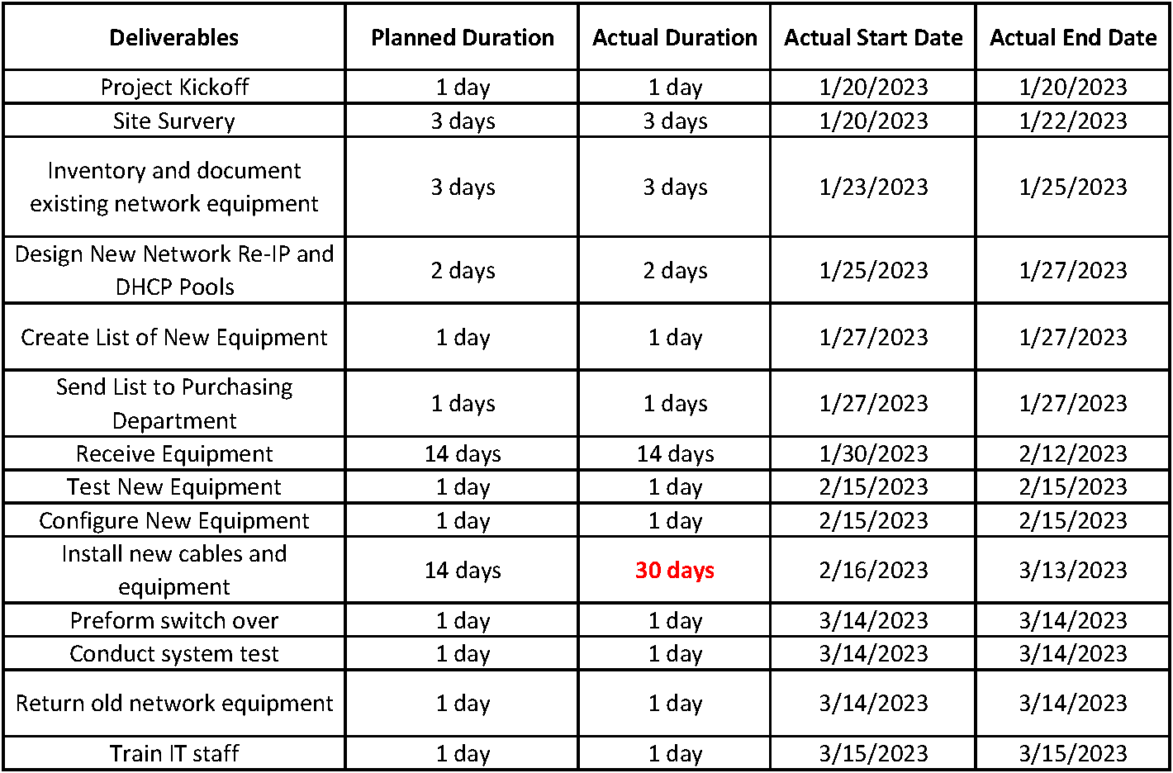

The original project timeline was started on 1/20/23 and started on time as planned. Once the project kickoff meeting had concluded site survey and taking an inventory of the existing equipment took place on the same day. There were no significant delays in the project until the cable installation took place. During this time it was discovered that one of the lines connecting two of the buildings was damaged and had to be dug out and repaired and concrete had to be poured and set. As a result, this delay caused the project to slip while this line was being unburied and worked on. While this work was taking place all cables that needed to be installed and everything was put in place so when the last piece of the milestone could be completed it could move right to the next. A second delay did occur but did not cause any minor delay. While a phone call was made to their service provider about a planned outage they mentioned how the company was experiencing a network upgrade and the service provider noted a free upgrade to support the new bandwidth. While work was still in wait on the concrete company the service provider sent out a technician and installed the new equipment. These delays all lead to a total of 14 days of delay to the project.

# Unanticipated Requirements

During this project, two obstacles caused the project to take longer than expected. The first was discovered during fiber installation between buildings 2 and 3. During this phase, it was discovered that the ground conduit had collapsed and the cable could not be pulled through. To rectify this, the concrete had to be removed, the conduit line repaired then new cement poured. This damaged conduit caused a delay in the project by 2 weeks because the cabling was over a frequently used driveway.

The second unanticipated requirement occurred when the circuit and ISP modem had to be upgraded to support the new bandwidth needs of the company, otherwise, this would be a choke point in the network. Since this was discovered during the beginning of the installation phase this did not affect the schedule as this upgrade took place at the same time. As for the circuit and modem upgrade, this was at no cost to the customer as this was included with their business internet plan.

# Conclusions

When implementation was complete, B & B Manufacturing had a stable reliable, and redundant network. Employees no longer had trouble logging in or accessing network resources. The success of this project was determined by the positive and helpful response from the administrative and on-site IT staff. A major determining factor of the success of this project is that not a single network crash or slowdown – even during peak business hours- had occurred since the installation of the new equipment. Administrative staff commented on how the network shares did not “pause “or “hesitate” when opening frequently used folders like before. Tool crib and shop floor attendants commented on how quickly and more responsive the system preformed.

The network upgrade project was vital to prevent unreliable connectivity issues from occurring throughout the manufacturing floor. This new network allowed manufacturing employees to sign off on jobs to move them further down the assembly line without dropouts or freezes. It also helped the shipping department which relied on the wireless network to scan finished boxes for UPS shipments. As for suppliers and visitors, the new integration of VLANs helps keep the company network safe from any possible risks from unmanaged devices. When the time comes for the company to select and install the VOIP equipment provider they will be confident the network is ready for whomever they choose. I followed up with the IT department once a week for a month to verify that the network is functioning and performing as expected. This project was considered a success when the network had maintained an uptime (using the show version command) of 98% for a week over the course of the month with random sampling made across distinct switches.

# Project Deliverables

This section describes at least two project artifacts (examples) that appear in the appendices. The artifacts should provide a logical display to substantiate the described successes and benefits of the completed project. Refer to each appendix item (included after the References section as Appendix A, Appendix B, etc.) and describe how it demonstrates evidence of the project's completion. Artifacts may include code samples, screenshots, photos, flowcharts, process diagrams, tables, graphs, network diagrams (before and after), training materials or related documents (e.g., policies), etc. This is a new Section.

References

List all the outside sources that the narrative refers to in-text. For in-text and reference list citations, please refer to the web link in the Course of Study or visit the WGU Writing Center.

Note: Ensure that you have an in-text citation for each full citation and vice versa. Those citation pairs must match up according to APA formatting. For example:

In his seminal work describing not very important things about things nobody cares about, Ashe discusses the importance of proper kerning when writing medieval sonnets (Ashe, 2022).

# References

Ashe, J. (2022, October 32). *Pokémon Scarlet and Pokémon Violet Coming to Nintendo Switch.* Retrieved November 32, 2022, from https://www.pokemon.com/us/pokemon-news/pokemon-scarlet-and-pokemon-violet-coming-to-nintendo-switch/.

Use [MS Word's 'reference' feature](https://support.microsoft.com/en-us/office/create-a-bibliography-citations-and-references-17686589-4824-4940-9c69-342c289fa2a5) to manage citations and your reference page. Use this [APA Quick Reference](https://drive.google.com/open?id=1cA2sMO-VCODKjnqDwvVWfO_wiHgigLVe), follow the style of this [Task 2 Proposal Example](https://drive.google.com/file/d/1g9hN5GC3n5dqKM4BeFSitJ5R12I8aJSJ/view?usp=sharing), and these formatting guidelines:

* For *B. Other Works* have at least **three different** works referenced using in-text citations.
* For every reference listed, have at least one in-text citation in APA style.
* Use consistent formatting.
* Use hanging Indent.
* Right-click to remove hyperlinks.

Appendix A

# Before and After Network Topology and Site Map

Appendix A contains a before and after network topology diagram and site map. Included in the diagram are the switch model, connection speeds between the switches, and if the link is port channel (redundant pair). The notes on how the network changed throughout the project are included for points of reference.

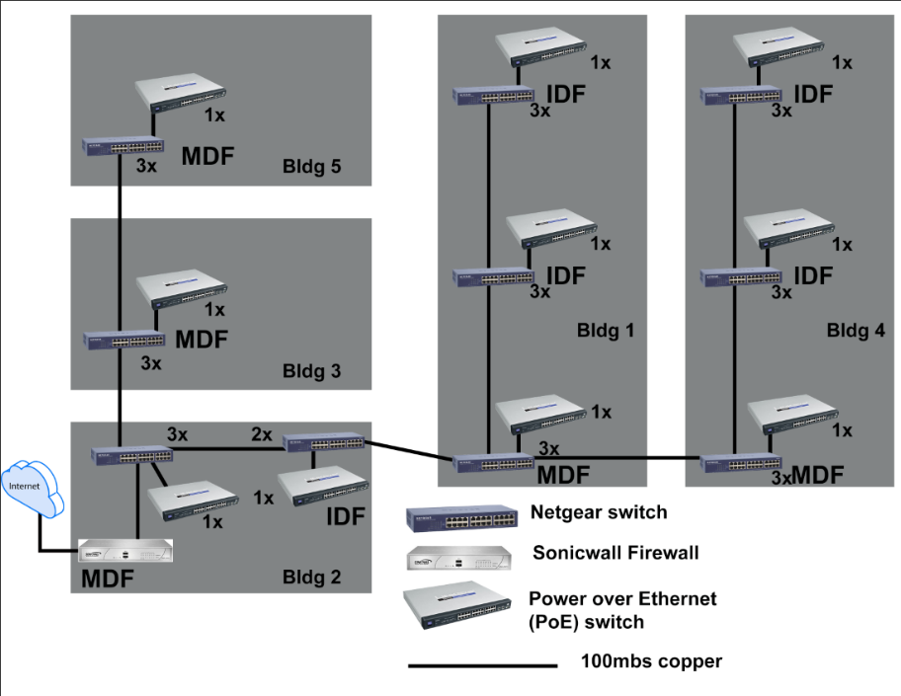

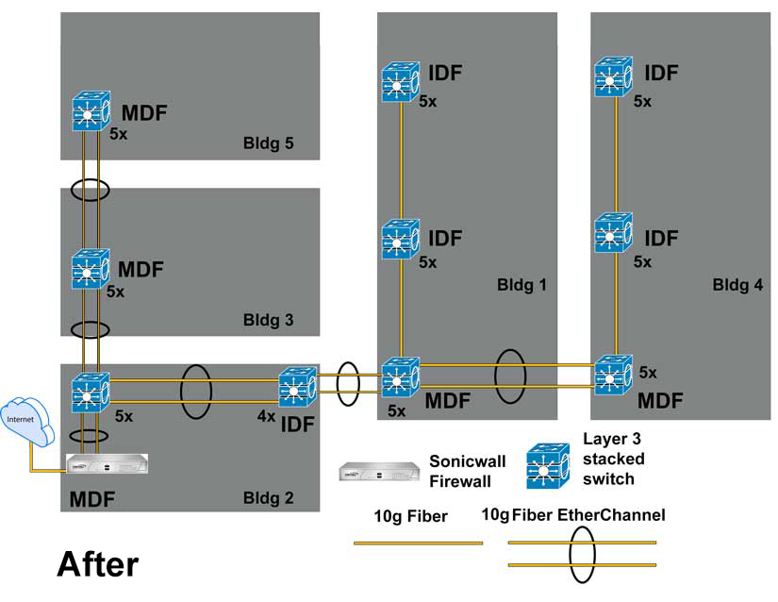

# Appendix B

# Network Inventory and Passwords

Put any supporting material in these appendices. Add additional or delete superfluous appendices as needed.  
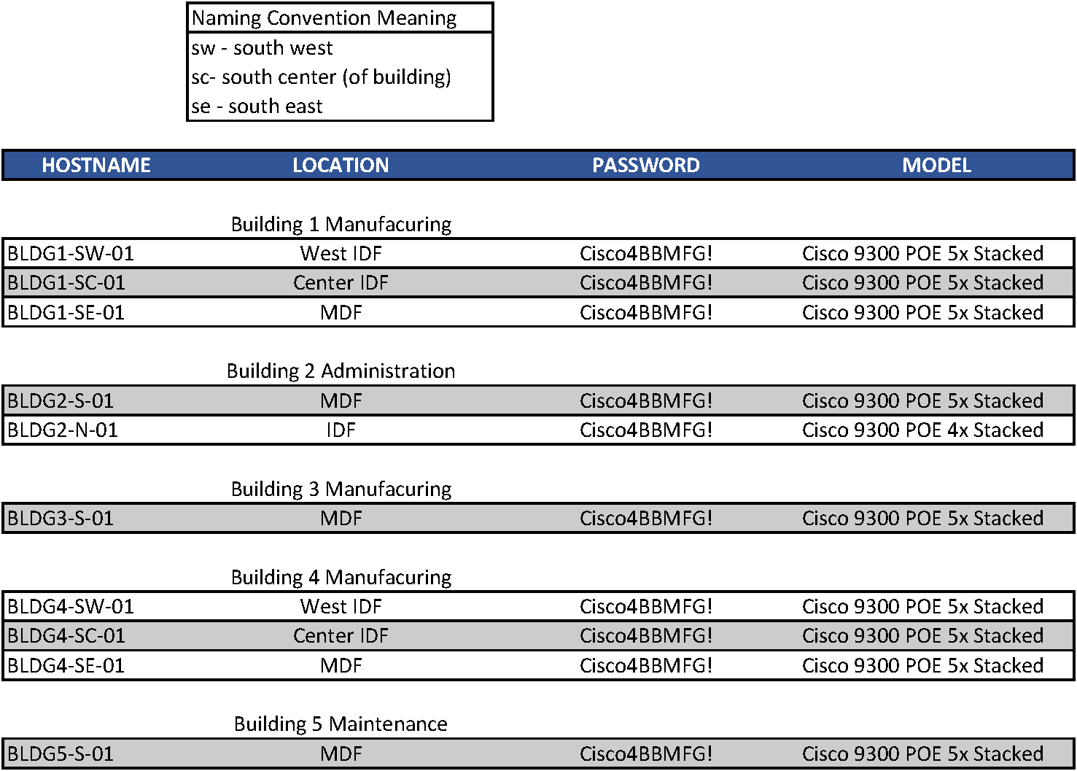

# Appendix C

# Title of Appendix

Put any supporting material in these appendices. Add additional or delete superfluous appendices as needed.